Lab 10 – GWAS

Your name: VIVIAN URAMA

Your GitHub link: https://github.com/vivianurama

1. Summarize important results of your GWAS activity.

In the GWAS activity, the main result in R is displayed in tabular form showing SNPS (single nucleotide polymorphism), chromosome number, position and most importantly P-value. The p value shows if the SNP is significantly associated with the phenotype evaluated. P-value less than 5% means there is significant association between the SNP and the trait while a P-value greater than 5% means no significant association. A p-value of 1 for a specific SNP means that there is no evidence of association between that SNP and the trait or phenotype being studied while the lowest p-value corresponds to the strongest statistical association between a specific SNP and the trait or phenotype being studied.

In the GWAS activity for the trait ear diameter, the SNP PZA00453.7 had the lowest p-value (0.0002) indicating that it has the strongest association with ear diameter amongst other SNPs.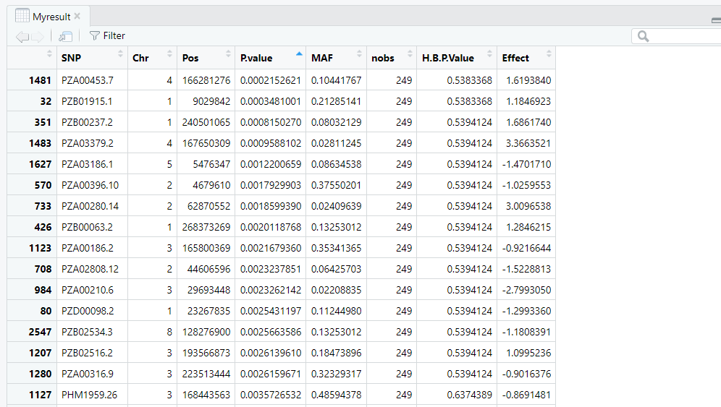

The GWAS activity involved generating Manhattan plot as displayed below. This Manhattan plot summarizes the results of a Genome-Wide Association Study (GWAS) for the phenotype ear diameter. The x-axis represents chromosomes (1 through 10), showing the genomic position of single nucleotide polymorphisms (SNPs). The y-axis represents the negative log10 of the p-value indicating the statistical significance of the association between each SNP and ear diameter. Because it is a negative log, the highest value on the graph depicts the most significantly associated SNP.

Each dot is a SNP, with alternating black and red colors used to differentiate chromosomes for visual clarity. A red horizontal line marks the genome-wide significance threshold (commonly set at −log10(p)≈3.5), used to determine SNPs significantly associated with the trait.

One SNP is highlighted in green on Chromosome 4, which exceeds the significance threshold — this is the most significant SNP, suggesting a strong association with ear diameter. This green-highlighted SNP may warrant further investigation as a potential genetic factor influencing ear diameter.

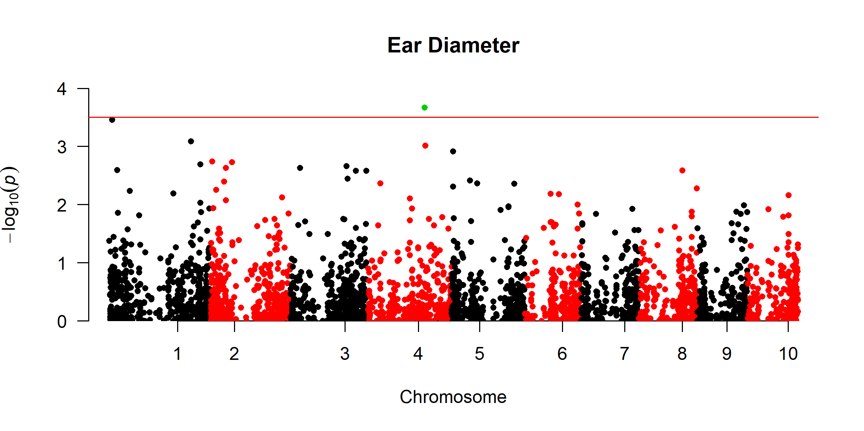

1. Search for more information about GWAS and describe the most interesting part.

The most interesting I learnt from the GWAS manual is the multi-trait/multi-method GWAS visualization which refers to an advanced functionality in GAPIT (a GWAS analysis tool in R) that uses MVP (Memory-efficient, Visualization-enhanced, and Parallel-accelerated GWAS) library features.

In the class activity, the analysis was done one for each trait hence it was interesting to learn that instead of showing GWAS results for just one trait, one environment, or one method, this approach combines results across multiple traits, multiple environments or multiple statistical models/methods. This multi-trait/multi-method GWAS gives a holistic view of associations that are consistent across different setups — making the findings more reliable and robust.

The multi trait Manhattan Plots are of two types; Orthogon Manhattan Plot which refers to traditional side-by-side or overlaid Manhattan plots across different traits or models that helps see how signals compare trait-to-trait or method-to-method and Roundness Manhattan Plot that Possibly refers to a more circular/radial visualization which is used for high-dimensional comparisons or visual symmetry across traits/methods. It is helpful when comparing many traits or overlapping genomic regions.

In the figure below, Manhattan plot for two traits; Ear height and Ear diameter was developed simultaneously.

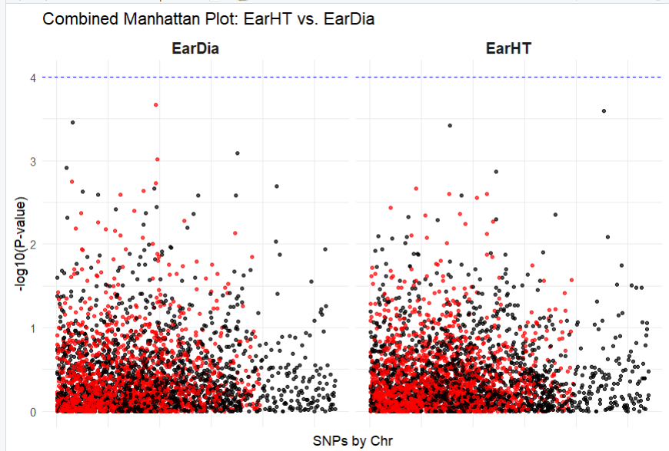

1. Save your files, upload it to your GitHub, and share the link of that GitHub webpage above (below your name).